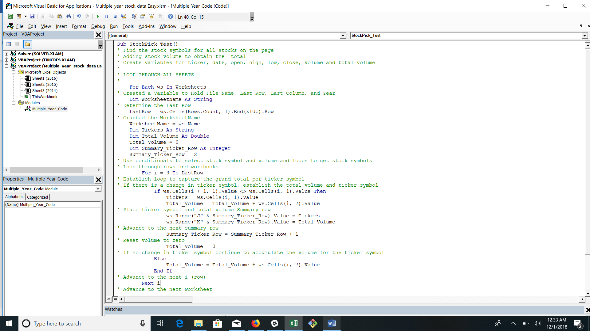

Sub StockPick_Test()

' Find the stock symbols for all stocks on the page

' Adding stock volume to obtain the total

' Create variables for ticker, date, open, high, low, close, volume and total volume

' --------------------------------------------

' LOOP THROUGH ALL SHEETS

' --------------------------------------------

For Each ws In Worksheets

' Created a Variable to Hold File Name, Last Row, Last Column, and Year

Dim WorksheetName As String

' Determine the Last Row

LastRow = ws.Cells(Rows.Count, 1).End(xlUp).Row

' Grabbed the WorksheetName

WorksheetName = ws.Name

Dim Tickers As String

Dim Total_Volume As Double

Total_Volume = 0

Dim Summary_Ticker_Row As Integer

Summary_Ticker_Row = 2

' Use conditionals to select stock symbol and volume and loops to get stock symbols

' Loop through rows and workbooks

For i = 3 To LastRow

' Establish loop to capture the grand total per ticker symbol

' If there is a change in ticker symbol, establish the total volume and ticker symbol

If ws.Cells(i + 1, 1).Value <> ws.Cells(i, 1).Value Then

Tickers = ws.Cells(i, 1).Value

Total_Volume = Total_Volume + ws.Cells(i, 7).Value

' Place ticker symbol and total volume Summary row

ws.Range("J" & Summary_Ticker_Row).Value = Tickers

ws.Range("K" & Summary_Ticker_Row).Value = Total_Volume

' Advance to the next summary row

Summary_Ticker_Row = Summary_Ticker_Row + 1

' Reset volume to zero

Total_Volume = 0

' If no change in ticker symbol continue to accumulate the volume for the ticker symbol

Else

Total_Volume = Total_Volume + ws.Cells(i, 7).Value

End If

' Advance to the next i (row)

Next i

' Advance to the next worksheet

Next ws

' End program

End Sub